1️⃣ What is Recursion Tree Method?
The Recursion Tree Method is used to solve recurrence relations of divide-and-conquer algorithms.
It works by:
- Expanding the recurrence level by level.
- Drawing it like a tree.
- Calculating cost at each level.
- Adding all level costs.
- Finding final Θ complexity.

🔹 2️⃣ General Form of Recurrence
Most divide & conquer recurrences look like:
$$T(n)=aT(n/b)+f(n)$$
Where:
- a → number of subproblems
- b → division factor
- f(n) → extra work done at each level

🔹 3️⃣ Steps to Solve Using Recursion Tree
STEP 1 → Draw first few levels
STEP 2 → Find pattern
STEP 3 → Find cost at level i
STEP 4 → Find height of tree
STEP 5 → Add total cost

🔥 SOLVED EXAMPLE
$$T(n)=4T(n/2)+n^{2}$$

🌳 STEP 1: Draw Recursion Tree
Level 0:
n²
Level 1:
Each node splits into 4 subproblems of size n/2.
n²
/ / \ \
(n/2)² (n/2)² (n/2)² (n/2)²
Level 2:
Each of those splits again into 4:
Total nodes = 4² = 16
Size = n/4

🌳 STEP 2: Cost at Level i
At level i:
Number of nodes:
$$4^{i}$$
Size of each subproblem:
$$n/2^{i}$$
Cost per node:
$$\left(n/2^{i})^{2} = n^{2}/4^{i}\right.$$
Total cost at level i:
$$4^{i}×(n^{2}/4^{i})=n^{2}$$
🔥 Important observation:
Cost per level = n²
(Same at every level)

🌳 STEP 3: Height of Tree
Recursion stops when size becomes 1:
$$n/2^{h}=1 \\ h={log⁡}_{2}n$$
So total levels = log₂ n

🌳 STEP 4: Total Cost
Since each level costs n² and number of levels is log n:
$$T(n)=n^{2}+n^{2}+n^{2}+...(log⁡n\text{ times}) \\ T(n)=n^{2}log⁡n$$

✅ Final Answer
$$\boxed{T(n)=Θ(n^{2}log⁡n)}$$

🔥 4️⃣ Important Patterns (Very Important for Exam)
When solving:
$$T(n)=aT(n/b)+f(n)$$
There are 3 cases:

📌 CASE 1: Cost decreases each level
If:
$$a<b^{k}$$
→ Root dominates
Final:
$$Θ(f(n))$$
Example:
$$T(n)=2T(n/3)+n$$
Answer:
$$Θ(n)$$

📌 CASE 2: Cost same each level
If:
$$a=b^{k}$$
→ Multiply by height
Final:
$$Θ(f(n)log⁡n)$$
Example:
$$T(n)=4T(n/2)+n^{2}$$
Answer:
$$Θ(n^{2}log⁡n)$$

📌 CASE 3: Cost increases each level
If:
$$a>b^{k}$$
→ Leaves dominate
Final:
$$Θ(n^{{log⁡}_{b}a})$$
Example:
$$T(n)=5T(n/2)+n$$
Answer:
$$Θ(n^{{log⁡}_{2}5})$$

🔹 5️⃣ Why We Use Θ Notation?
Because recursion tree gives the exact tight bound.
So we write:
$$\boxed{Θ(...)}$$
Not just O(...)

🔹 6️⃣ Final Exam Shortcut
At level i:
- Nodes = $a^{i}$
- Size = $n/b^{i}$
- Cost per node = $f(n/b^{i})$
Total level cost:
$$a^{i}×f(n/b^{i})$$
Then:
- Find height
- Add all levels
- Identify which level dominates

🎯 Final Quick Revision Formula
$$T(n)=aT(n/b)+f(n)$$
Compare:
$$n^{{log⁡}_{b}a}$$
With:
$$f(n)$$
Then decide which case.

🧠 Final Memory Trick
If cost:
- Shrinks → root dominates
- Same → multiply by log n
- Grows → leaves dominate

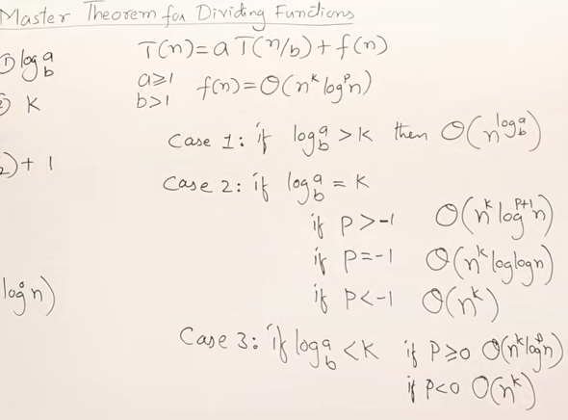

Asymptotic Notations and Their Purpose in Algorithm Analysis
🔹 Introduction
Asymptotic notations are mathematical tools used to describe the running time or space complexity of algorithms as input size $n→∞$.
They help analyze:
- Growth rate of algorithms
- Performance for large inputs
- Machine-independent efficiency
They ignore:
- Constant factors
- Lower-order terms

🎯 Purpose in Algorithm Analysis
- To compare algorithms independent of hardware.
- To measure efficiency for very large inputs.
- To express worst, best, and exact performance.
- To simplify complex time functions.

🔥 Types of Asymptotic Notations

1️⃣ Big-O Notation — $O(g(n))$
🔹 Definition:
A function $f(n)$belongs to $O(g(n))$if there exist positive constants $c$and $n_{0}$such that:
$$0≤f(n)≤cg(n)\text{for all }n≥n_{0}$$
🔹 Meaning:
Represents the upper bound of an algorithm (usually worst-case).
🔹 Purpose:
Ensures the algorithm does not grow faster than a certain rate.

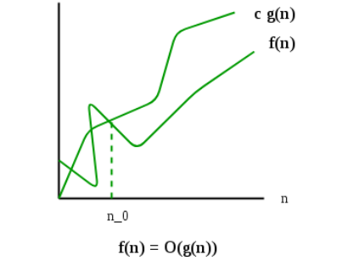

2️⃣ Big-Ω Notation — $Ω(g(n))$
🔹 Definition:
$$f(n)∈Ω(g(n))$$
if there exist positive constants $c$and $n_{0}$such that:
$$f(n)≥cg(n)\text{for all }n≥n_{0}$$
🔹 Meaning:
Represents the lower bound (usually best case).

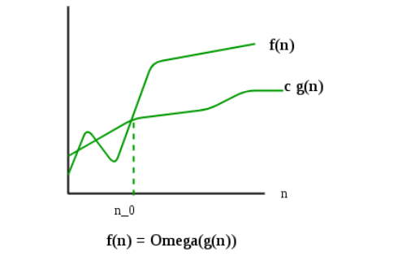

3️⃣ Big-Θ Notation — $Θ(g(n))$
🔹 Definition:
$$f(n)∈Θ(g(n))$$
if there exist positive constants $c_{1},c_{2}$and $n_{0}$such that:
$$c_{1}g(n)≤f(n)≤c_{2}g(n)\text{for all }n≥n_{0}$$
🔹 Meaning:
Represents the tight bound (exact order of growth).

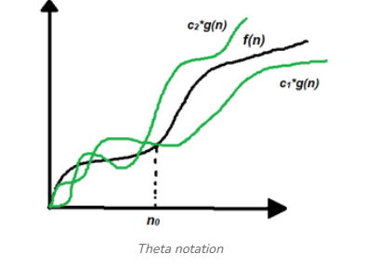

.
0/1 Knapsack Problem – Brute Force Approach
1. Introduction
The given problem is a 0/1 Knapsack Problem, where:
- Each item has a weight (w) and value (v).
- The knapsack has a maximum capacity K = 50.
- Each item can either be selected (1) or not selected (0).
- Objective: Maximize total value without exceeding capacity.

2. Given Data
Weights:
w = [10, 20, 30, 5, 15, 25, 35, 45, 22, 28]
Values:
v = [60, 100, 120, 40, 75, 90, 130, 150, 110, 125]
Capacity:
K = 50
Number of items:
n = 10

3. Brute Force Approach
The brute force method:
- Generate all possible subsets of items.
- Calculate total weight and total value for each subset.
- Discard subsets where weight > 50.
- Choose the subset with maximum value among valid subsets.
Total possible subsets:
$$2^{n}=2^{10}=1024$$
Hence, 1024 combinations must be checked.

4. Checking Optimal Combinations
We examine combinations whose total weight ≤ 50.
Important Profitable Combinations:
Items (Weight) | Total Weight | Total Value
20 + 30 | 50 | 100 + 120 = 220
10 + 15 + 25 | 50 | 60 + 75 + 90 = 225
5 + 15 + 30 | 50 | 40 + 75 + 120 = 235
22 + 28 | 50 | 110 + 125 = 235
5 + 10 + 15 + 20 | 50 | 40 + 60 + 75 + 100 = 275

5. Optimal Solution
The best combination is:
Weights: 5, 10, 15, 20
Total Weight:
$$5+10+15+20=50$$
Total Value:
$$40+60+75+100=275$$
✅ Maximum Value = 275

6. Final Answer
Selected Items:
(Weight, Value)
- (5, 40)
- (10, 60)
- (15, 75)
- (20, 100)
Total Weight = 50
Maximum Total Value = 275

7. Time Complexity
Brute force checks all subsets:
$$2^{n}$$
For n items:
$$T(n)=O(2^{n})$$
For n = 10:
$$2^{10}=1024$$
Hence, time complexity is Exponential.

8. Space Complexity
Only subset storage required:
$$O(n)$$

9. Conclusion
- The problem is solved using 0/1 Knapsack Brute Force.
- All possible combinations are examined.
- Optimal value obtained is 275.
- Brute force guarantees correct solution but is inefficient for large n due to exponential complexity.
.
.

Mathematical Analysis of Non-Recursive Algorithms
1. Introduction
Mathematical analysis of an algorithm is the process of determining the running time of an algorithm as a function of input size n using mathematical tools.
It helps us measure the efficiency of the algorithm in terms of time and space complexity.
In non-recursive algorithms, loops and simple statements determine the running time. These algorithms do not call themselves.

2. What is Time Complexity?
Time Complexity is a measure of the total time taken by an algorithm in terms of the number of fundamental operations executed as a function of input size n.
We express time complexity using Big-O notation, which describes the upper bound of runtime.

3. Steps in Mathematical Analysis
To analyze a non-recursive algorithm:
- Identify the basic operation — the operation that contributes most significantly to running time (e.g., comparison, assignment).
- Count how many times the basic operation is executed with respect to input size n.
- Express the count using mathematical expressions, often summations.
- Simplify the expression using rules of algebra and known formulae.
- State the time complexity using Big-O notation.

4. Examples of Analysis
Example 1: Single Loop
for (i = 0; i < n; i++)
sum++;
- Basic operation: sum++
- Loop runs n times
Number of operations:
$$T(n)=n$$
⟶ Time Complexity:
$$\boxed{O(n)}$$

Example 2: Nested Loops
for (i = 0; i < n; i++)
for (j = 0; j < n; j++)
count++;
- Outer loop runs n times
- Inner loop runs n times for each outer iteration
Total operations:
$$n×n=n^{2}$$
⟶ Time Complexity:
$$\boxed{O(n^{2})}$$

Example 3: Summation Loop
for (i = 0; i < n; i++)
for (j = 0; j <= i; j++)
count++;
Number of operations:
$$1+2+3+...+n$$
Using summation formula:
$$\sum_{k=1}^{n}{k=}\frac{n(n+1)}{2}$$
⟶ Time Complexity:
$$\boxed{O(n^{2})}$$

Example 4: Logarithmic Loop
for (i = 1; i < n; i = i * 2)
count++;
Values of i:
1, 2, 4, 8, ..., n
Number of iterations:
$${log⁡}_{2}n$$
⟶ Time Complexity:
$$\boxed{O(log⁡n)}$$

5. Space Complexity
Space complexity measures the extra space required by the algorithm.
For non-recursive algorithms with only a few variables, space complexity is usually constant:
$$\boxed{O(1)}$$

6. Best, Average and Worst Case
- Best Case — minimum operations possible
- Average Case — expected operations on random input
- Worst Case — maximum operations
In mathematical analysis, we normally consider the worst case.

7. Why Mathematical Analysis?
Mathematical analysis:
✔ Helps compare different algorithms
✔ Predicts performance for large inputs
✔ Uses algebraic techniques and summation
This is more precise than empirical measurements.

8. Conclusion
Mathematical analysis of non-recursive algorithms involves:
- Choosing the basic operation
- Counting number of times it executes
- Using loop counts and summations
- Deriving time complexity in terms of n
Common results:
Loop Type | Time Complexity
Single loop | O(n)
Nested loops | O(n²)
Logarithmic loops | O(log n)
Thus, mathematical analysis provides a reliable way to evaluate efficiency without running the algorithm.
.
.
2. Examples and Efficiency Analysis

✅ 1️⃣ Linear Search
Algorithm Idea:
Search element sequentially from beginning to end.
Basic Operation:
Comparison
Time Analysis:
- Best Case (element at first position):
$$O(1)$$
- Worst Case (element at last position or not present):
$$O(n)$$
- Average Case:
$$O(n)$$
Efficiency:
Efficient for small datasets, inefficient for large unsorted data.

✅ 2️⃣ Bubble Sort
Algorithm Idea:
Repeatedly compare adjacent elements and swap if necessary.
Basic Operation:
Comparison
Mathematical Analysis:
Outer loop runs $n-1$times
Inner loop runs $n-i-1$times
Total comparisons:
$$(n-1)+(n-2)+...+1 \\ =\frac{n(n-1)}{2}$$
Time Complexity:
- Best Case (already sorted):
O(n) \] (if optimized) - Worst Case: \[ O(n^2)
- Average Case:
$$O(n^{2})$$
Efficiency:
Poor for large inputs.

✅ 3️⃣ Selection Sort
Algorithm Idea:
Select minimum element and place at correct position.
Analysis:
Always performs:
$$\frac{n(n-1)}{2}$$
comparisons.
Time Complexity:
- Best Case:
$$O(n^{2})$$
- Worst Case:
$$O(n^{2})$$
- Average Case:
$$O(n^{2})$$
Efficiency:
Performance does not depend on input order.

✅ 4️⃣ Insertion Sort (Iterative)
Mathematical Analysis:
Worst case (reverse order):
$$1+2+3+...+(n-1) \\ =\frac{n(n-1)}{2}$$
Time Complexity:
- Best Case:
$$O(n)$$
- Worst Case:
$$O(n^{2})$$
- Average Case:
$$O(n^{2})$$
Efficiency:
Efficient for nearly sorted arrays.

✅ 5️⃣ Binary Search (Iterative)
Algorithm Idea:
Divide sorted array into halves repeatedly.
At each step:
$$n→n/2→n/4→...$$
Number of steps:
$${log⁡}_{2}n$$
Time Complexity:
- Best Case:
$$O(1)$$
- Worst Case:
$$O(log⁡n)$$
- Average Case:
$$O(log⁡n)$$
Efficiency:
Highly efficient for large sorted data.

📊 3. Efficiency Comparison Table
Algorithm | Best Case | Worst Case | Efficiency Type
Linear Search | O(1) | O(n) | Linear
Bubble Sort | O(n) | O(n²) | Quadratic
Selection Sort | O(n²) | O(n²) | Quadratic
Insertion Sort | O(n) | O(n²) | Quadratic
Binary Search | O(1) | O(log n) | Logarithmic
.
.

